U.S. Radiocommunication Sector
Fact Sheet
Working Party: ITU-R WP 7D | Document No: USWP7D_24-5A_NC
Ref. WRC-27 Agenda Item 1.16 | Date: 08/15/2024
Document Title: Working Document Towards a Preliminary Draft New Report: Coexistence Measures between non-GSO satellite systems and RAS stations in the Radio Quiet Zones supporting the Square Kilometre Array (SKA) and the Atacama Large Millimeter/submillimeter Array (ALMA)
Author(s)/Contributors(s):  Frank Schinzel, National Science Foundation  Chris De Pree, National Radio Astronomy Observatory  Brian Schepis, SpaceX  Jonathan Williams, National Science Foundation  Sarah Marie Bruno, Johns Hopkins University | fschinze@nsf.gov  cdepree@nrao.edu  brian.schepis@spacex.com  jonwilli@nsf.gov  sbruno3@jhu.edu
Purpose/Objective: To provide information about experiences and coexistence strategies between the radio astronomy service and NGSOs at the Radio Quiet Zones supporting the SKA and ALMA.

Abstract: Following Resolves 5 of WRC-27 Agenda Item 1.16, this new Report studies new coexistence measures between non-GSO satellite systems and RAS stations in the specific RQZs surrounding the SKA-Mid and ALMA telescopes.

Radiocommunication Study Groups | 
Received: | Document 7D/XX
 | X September 2024
 | English only
United States of America
Working Document towards a Preliminary Draft New Report ITU-R RA.[NGSO-RAS-RQZ]
Coexistence Measures between non-GSO satellite systems and RAS stations in the Radio Quiet Zones supporting the Square Kilometre Array (SKA) and the Atacama Large Millimeter/submillimeter Array (ALMA)
Summary
Resolution 681 (WRC-23) resolves to study new coexistence measures between non-GSO satellite systems and RAS stations in specific RQZs. This new report provides results of the requested studies under this resolves for the two specific RQZs specified for the Square Kilometre Array Observatory in South Africa and the Atacama Large Millimeter/submillimeter Array (ALMA) in Chile. The United States is a key contributor to the cost of both the construction and operations of the ALMA Observatory with the North American ALMA Science Center (NAASC) being located in Charlottesville, VA.
The aim of this new Report is to provide a description of technical means that would enhance coexistence of the nationally regulated radio quiet zones in South Africa and Chile with non-GSO satellite constellations. It is noted that protection of RQZs is provided through sovereign domestic regulations.
Attachment: 1

ATTACHMENT
Working Document towards a Preliminary Draft New Report ITU-R RA.[NGSO-RAS-RQZ]
Coexistence Measures between non-GSO satellite systems and RAS stations in the Radio Quiet Zones supporting the Square Kilometre Array (SKA) and the Atacama Large Millimeter/submillimeter Array (ALMA)
TABLE OF CONTENTS
Page
1 Introduction 4
1.1 Properties of the ALMA Protection and Coordination Zones 4
1.2 Properties of the South African Astronomy Advantage Area 5
2 Considerations for coexistence measures between non-GSO satellite systems and RAS stations in specific RQZs 5
2.1 General Considerations 6
2.2 Considerations specific to the Square Kilometre Array (SKA), South Africa 6
2.3 Considerations specific to the Atacama Large Millimeter/submillimeter Array (ALMA), Chile 6
2.3.1 Approaches for Coexistence between ALMA and Satellite System Operators 6
3 Summary 6
4 Related ITU-R Recommendations/Reports 6
5 Abbreviations/Glossary 6

1 Introduction
Radio telescopes operating in remote areas have benefited for many years from broad access to the entire electromagnetic spectrum. Given the highly sensitive nature and weakness of the natural signals being detected, this has resulted in siting of RAS receivers by administrations in remote locations with extremely low population densities, as recommended by Rec. ITU-R RA.769-2 and more generally outlined in the Radio Regulations Article 29. Additional protections from terrestrial receivers are provided through sovereign domestic regulations that in some cases establish special coordination or radio quiet zones. For details on such zones refer to Report ITU-R RA.2259-1. However, as Rec. ITU-R RA.769-2 recommends 2 and 3 describe, as administrations seek to afford protection to particular radio astronomical observations, all practicable steps should be taken, including particularly from high altitude platform stations, spacecraft and balloons and when planning global systems.
This Report focuses specifically on studies called for in Resolution 681 (WRC-23) Resolves 5 of new coexistence measures between non-GSO satellite systems and RAS stations in the RQZs specified to be located around:
- The Square Kilometre Array Observatory (SKAO) in South Africa;
- The Atacama Large Millimeter/submillimeter Array (ALMA) in Chile.
The Report is laid out as follows: properties of the ALMA and South African radio quiet zones in Sections 1.1 and 1.2, general and specific considerations for coexistence measures in Section 2, and a summary in Section 3.
[Editor’s Notes: This specifically lists the two RQZs called out under A.I. 1.16, and would be expected to provide additional technical information as it applies directly to the operating frequencies and geographic areas of these two RQZs, but will not repeat supplementary information already provided in RA.2259-1.]

1.1 Properties of the ALMA Protection and Coordination Zones

The Atacama Large Millimeter/submillimeter Array (ALMA), an international astronomy facility, is a partnership of the European Organisation for Astronomical Research in the Southern Hemisphere (ESO), the U.S. National Science Foundation and the National Institutes of Natural Sciences (NINS) of Japan in cooperation with the Republic of Chile. ALMA construction and operations are led by ESO on behalf of its Member States; by the NSF National Radio Astronomy Observatory (NRAO), managed by Associated Universities, Inc. (AUI), on behalf of North America; and the National Astronomical Observatory of Japan (NAOJ) on behalf of East Asia.
The ALMA radio telescope is situated in an uninhabited region of northern Chile at an elevation of 5 000 m. To protect the operations of the ALMA telescope, the ALMA partners must abide by the regulations of the Chilean national telecommunications authority SUBTEL and the identical Resolution 1055 issued to AUI for North America and Resolution 1056 to the European Southern Observatory (ESO) in August 2004. The English-language translation of Resolution 1055 is presented in Attachment 1 to Annex 3 in Report ITU-R RA.2259-1.

In May 2003, AUI and ESO signed the acquisition from the Chilean Ministry of National Assets of land for the ALMA Operations Support Facility. In November 2003, the Chilean Ministry of National Assets provided a 50-year land concession for the construction and operation of ALMA on the Chajnator Altiplano, an area known as “the ALMA Concession.” In 2013, the land was designated for exclusive use of scientific activities and the National Commission for Research in Science and Technology (CONICYT) created the Parque Astronomico de Atacama (PAA) for managing the land concession. The PAA defined two zones centered
on 23º 01’ S by 67º 45’ W:
i) Protection Zone: with a radius of 30 km, within Chilean national territory. Third-party transmitters operating within certain frequency bands may not be stationed within this zone.
ii) Coordination Zone: with a radius of 120 km, within Chilean national territory. Operators wishing to station certain kinds of transmitters within this zone are subject to a process whereby the opinion of the petitioners, ESO and AUI, are sought regarding requests that could interfere or affect the operation of the radio telescope.

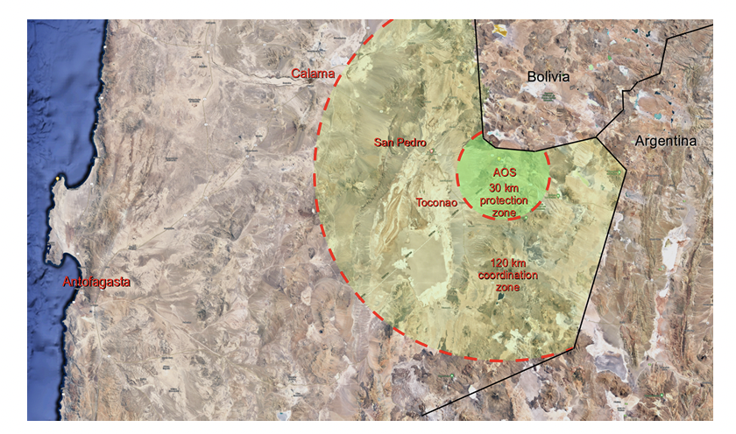
Fig. 1: ALMA protection and coordination zones, as defined by the SubTel Exempt Resolutions, with a radius of 30 and 120 km respectively within the Chilean territory. The black line shows the border between Chile, Bolivia, and Argentina.

1.2 Properties of the South African Astronomy Advantage Area
[Describe South African radio quiet zone details here that are pertinent from the Report ITU-R RA.2259 as well as telescope system characteristics relevant for this report.]

2 Considerations for coexistence measures between non-GSO satellite systems and RAS stations in specific RQZs
[Editor’s Notes: This specifically lists results from studies that directly apply to new coexistence measures between nGSO and the two RAS facilities situated in the two RQZs to be studied]

2.1 General Considerations
This analysis assumes the protection criteria as laid out in Recommendations ITU-R RA.769-2 and ITU-R RA.1513-2.
[Editor’s Notes: Provide more information on any general considerations here including approaches for coexistence of ground-based terminals and user terminals according to any national rules, and anything else that may be generally pertinent.]

2.2 Considerations specific to the Square Kilometre Array (SKA), South Africa

2.3 Considerations specific to the Atacama Large Millimeter/submillimeter Array (ALMA), Chile

A number of approaches could be taken to reduce or avoid potential corruption of astronomical data at the ALMA observatory.

2.3.1 Approaches for Coexistence between ALMA and Satellite System Operators
Given the operating frequencies of ALMA, satellites operating at altitudes of [typical altitudes], would be able to form small spot beams covering areas of [xxx-xxx km]. Approaches for coexistence between satellite operators and the observatory would allow for effective temporary boresight avoidance, while a particular observing band is in use. In addition, with sufficient separation, power levels from satellite systems could be minimized to be below thresholds specified in Recommendation ITU-R RA.769-1. Deployment of terminals and gateways are a matter of domestic regulation and are already covered under the protection zones specified and governed by licensing requirements through SUBTEL.
Possible approaches for coexistence that could be employed:
- Boresight Avoidance
- Temporal Avoidance and Frequency Hopping
- Reduction of transmit Power Levels

3 Summary

4 Related ITU-R Recommendations/Reports

Recommendation ITU-R RA.769-2
Recommendation ITU-R RA.1513-2
Report ITU-R RA.2259-1

5 Abbreviations/Glossary

The Atacama Large Millimeter/submillimeter Array (ALMA), an international astronomy facility, is a partnership of the European Organisation for Astronomical Research in the Southern Hemisphere (ESO), the U.S. National Science Foundation (NSF) and the National Institutes of Natural Sciences (NINS) of Japan in cooperation with the Republic of Chile. ALMA is funded by ESO on behalf of its Member States, by NSF in cooperation with the National Research Council of Canada (NRC) and the National Science and Technology Council (NSTC) in Taiwan and by NINS in cooperation with the Academia Sinica (AS) in Taiwan and the Korea Astronomy and Space Science Institute (KASI). ALMA construction and operations are led by ESO on behalf of its Member States; by the National Radio Astronomy Observatory (NRAO), managed by Associated Universities, Inc. (AUI), on behalf of North America; and by the National Astronomical Observatory of Japan (NAOJ) on behalf of East Asia. The Joint ALMA Observatory (JAO) provides the unified leadership and management of the construction, commissioning and operation of ALMA.

